Marmaris (West Side)
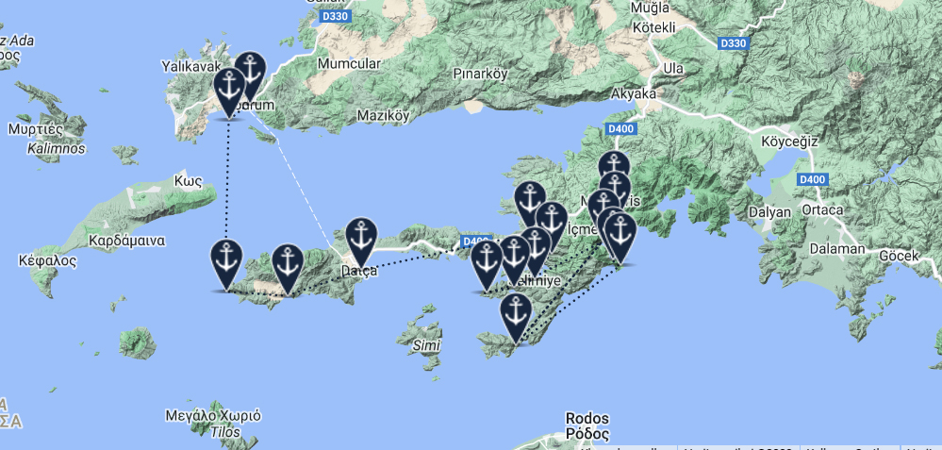

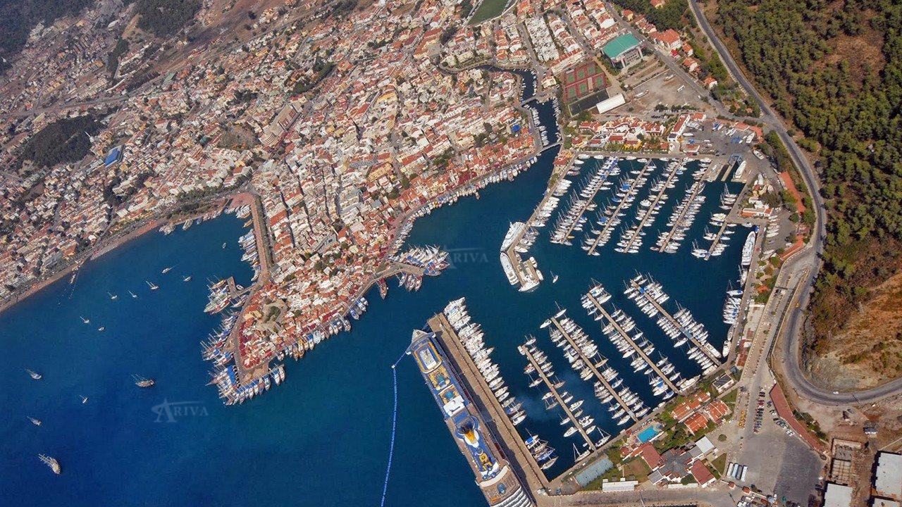33
Marmaris
Marmaris, a port city in the South West of Turkey has become an important tourist resort in recent times. The region is commonly called the ‘’Turquoise Coast’’ because of the beautiful colour of its waters all year round. There are many bays along this piece of coastline where yacht charters can anchor at will. As a natural harbour, Marmaris was an obvious place for development and today it has the capacity for taking 800 yachts. Marmaris is the gateway to a beautiful part of Turkey, rich in history, fertile and offering a whole range of things to see and do. Blue cruise facilities in Marmaris mean it is a logical starting point for tourists wanting to sail these lovely waters. Ashore, there are plenty of shops, bars and restaurants while at sea during the many months of blue skies, you can relax and enjoy the stunning surroundings.

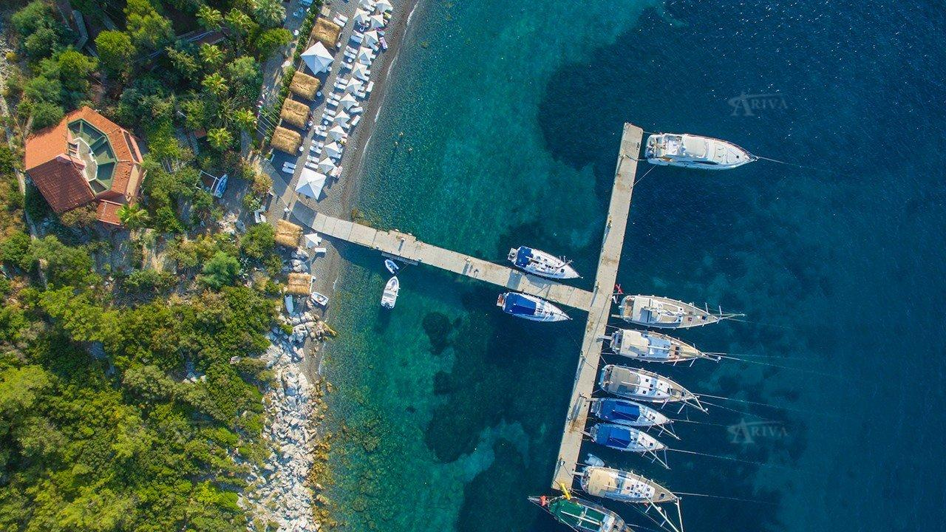
Kumlubuk Bay
Kumlubuk is a place where you can enjoy the lovely beaches, warm waters and of course the sun. The seafood restaurants are a real treat and every visitor should sample the fresh catch at least once before moving on. It is quieter than the towns further north so it is a great place to swim, away from the crowds.
Kumlubuk is a moon shaped large bay on S of Asarcık Burnu. It is open to E. The bay is surrounded by thickly wooded mountains. Kumlubuk provides all-round shetler except from easterlies. The depths gently shelve and drop to 10 m and the bottom becomes sand. Its shores feature long and sandy beach with sand bank by 2m off. There are two attractive anchorages on the southern shores. You can drop anchor in 10 m and take a line ashore. This anchorage is open to northerlies. The best shelter is in the northwest corner, off the beach; the bottom is sand and there is 5 to 6 m depth. Boats can be pushed off or anchored with a line ashore. There are several restaurants with piers along the coast. Water, electricity and wireless connections are available. Some of these restaurants offer exclusive service. Water sport activities are organized..
Pay attention for mooring lines distance, Rodos-Marmaris ferry and hydrofoils run daily, they produce considerable waves and the anchorage becomes boomy.
Land transport services are available toTurunç (4km), İçmeler(14 km) and Marmaris(26 km).
Kumlubuk is a favorite spot for the excursion boats. It is better to arrive in late afternoon and leave before noon the next day.
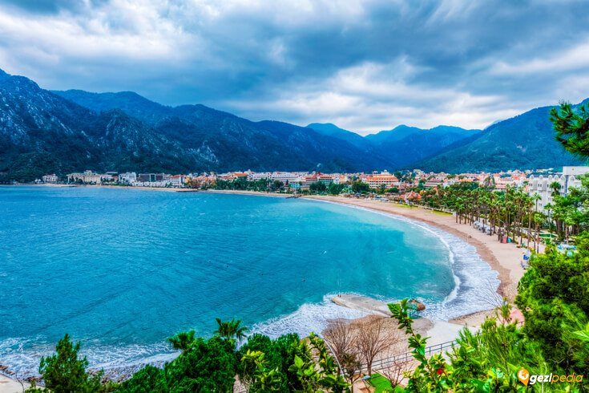
Icmeler
İçmeler is a popular Turkish holiday resort situated 8 kilometres southwest of Marmaris. It is also a municipality of its own. İçmeler Bay is located on the Datça Peninsula. The town is surrounded on three sides by pine forests. Hiking on the mountains is very popular and provides fantastic views of the region.
There are considerable depths in the passage (around 36m) and the passage is 38 m wide. There is an islet (Karga Adası) in the middle, you can safely pass either side of it. Approach from Marmaris is to be attempted from the south of Keçi Adası. A stream comes in the middle part of the beach. This side is shallow. Boats can be anchored off in 10-14m. The bottom is weed-sand. Strong westerlies push swell from the mountains. A quay on the south has berthing capacity up to 257 boats. Municipality administrates the port and charges berthig fee. An attendant will assist you a berth. Boats can anchor fore-and-aft if there is room. Water and electricty connections are available. Restaurants, cafes, shower and toilets are within the complex. Bilge water discharge service is provided. There is healing water outlet behind the quay. This healing water recovers digestive system because of its laxative effect. The name Gölenye has become İçmeler which means; place of potable water. There are a number of hotels, pensions, cafes and bars. The place gets crowded in summer. An attractive landscaped boulverad runs to Marmaris along the shore, the settings of the bay looks very attractive from this vantage point.All sort of provisions can be found from the markets .
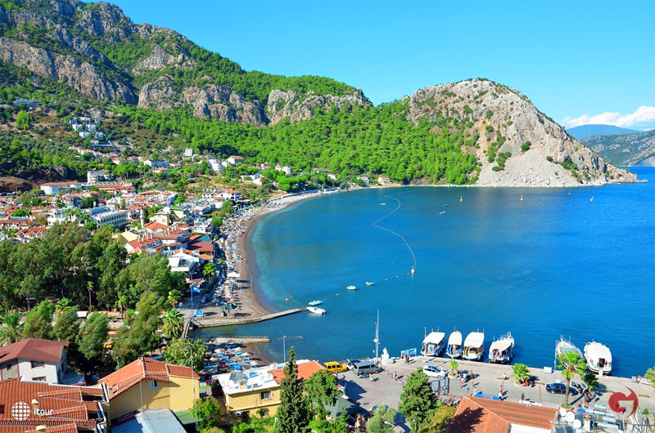
Turunc
Turunç is a Turkish holiday resort situated in the Marmaris district of Muğla Province, Turkey.
It is located 20 km (12 mi) south of Marmaris on the Mediterranean Sea, surrounded by the Taurus Mountains. The area is a former fishing village, and has been populated since ancient times as the sea offers a variety of precious resources. Despite the region's fast development in recent years, the natural environment of Turunç has been preserved. As a resort, the village has won the Blue Flag award in recognition of its clean beach and water quality. The size of Turunç is about 1 km (0.62 mi), taking half an hour to walk from one side to the other. The waterfront features restaurants, bazaars and bars. However, due to the nature of the resort there are few exclusively adult establishments.
Turunç has become one the prettiest spots in Marmaris with its real nice settings. All provisions can be found from the markets. Turunç is a favorite spot for divers.
The climate is warm, and enables the tourist season to be 7 months a year from April to October.
The bay is open to E. Turunç Bükü and/or Turunç Koyu affords sheltering from breeze. Strong westerlies send swell in. The valleys are thickly wooded with pine trees. There are reefs running out for about 180 m in the depth of 1m on W tip of the bay towards Zeytin Burnu. There are isolated rocks around Sarp Burun and there are rocky patches on the northern part of the bay, in the vicinity of point; Dümbek Burnu. Care is required.
The creek on the SE is the best shelter to be tucked up. The swimming area is cordoned off with buoys. Submarine communication cables are on the northern corner. Three yellow buoys indicate the cable line, one buoy flashes. A stream goes into sea on the southern side. There is a concrete quay with berthing capacity up to 70 boats. This quay gets crowded during the day. Yachts arrive in late afternoon and leave before noon the next day. The bottom is weed. Care is needed while anchoring, ease your chain as much as possible and make sure your anchor dug in well. Water and electricty connections are available. Fuel can be obtained from tanker-truck.

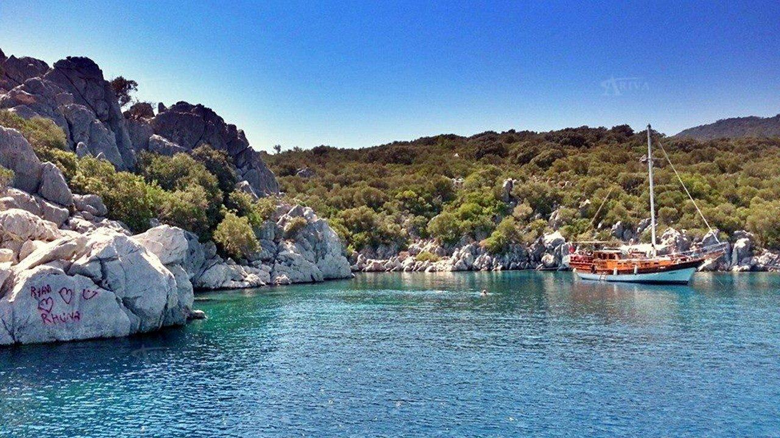
Kadirga Horbor
Kadirga Harbour is a pretty bay not far to the west from Marmaris. It is sheltered and has been awarded the blue flag because of its marvelous waters.
The entrance of the bay has no obstruction. There are sufficient depths. There is a rock by the tip on north. Kadırga Bay provides shelter from breeze and southerly blowing winds. It is open to northerly and easterly blowing winds. Prevailing wind sends light swell in. The depths gradually shelve ashore on the western part. The shore hosts nice shingle beaches.
Boats can be pushed off or anchored with a line ashore in SW, W and N shores of the bay, in 10-15m. There is a cove on NE part, the bottom is white debris. It is hard to heave the anchor to slip out from the bottom.
Steep rocks on SE are impressive platforms for cliff jumping.
Kadırga Koyu is a popular spot for the tripper boats from Marmaris during the day time and it is boomy anchorage because of power boats cruising. There is clear water in the bay. Scuba photo contests are organized here.

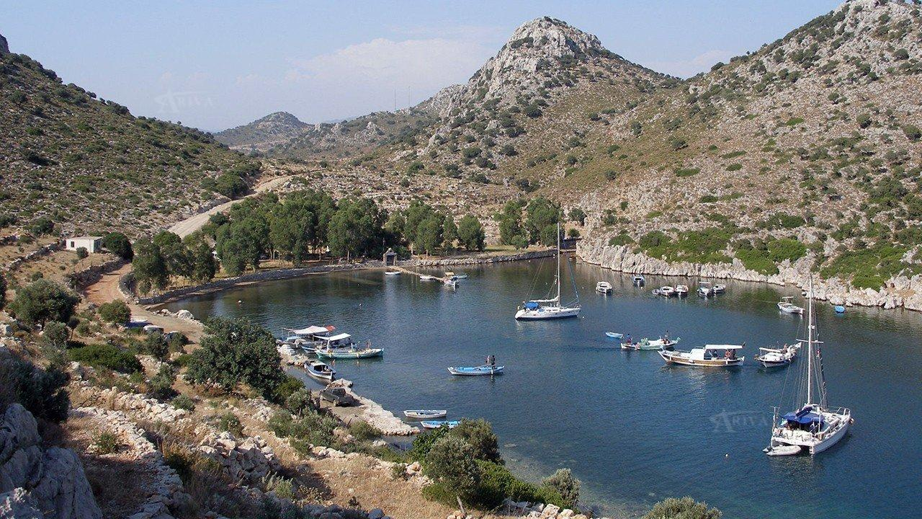
Serce Bay
Serce has become a regular blue cruise stop. It has a sheltered harbour with the clearest of water. Underwater excavations have found many valuable pieces from ancient times, glassware that is now housed in Bodrum’s Museum of Underwater Archaeology. There are two abandoned villages close by, Kirkkuyular and Sindilli where stone houses are evidence of previous times. In the former, which is thought to be the older of the two, there are 40 cisterns which provided the population with water in those days. Saline water is of little use for both animals and agriculture so houses needed wells for their domestic water and to grow their crops.
The narrow entrance (135m) of this bay between two high humped points, can not be identified from a distance. As you get closer, you can pick out the passage between steep points against the mainland behind it. Care is needed at the entry, there are reefs off the western point, extending out for about 10m. Glass objects were excavated from an 11th century Byzantine wreck. Serçe Limani is fjord-like; you get a kind of shiver at the entrance, with its huge steep rocks. The water in the bay is deep; 40 m at the entrance and 30m in the inlet. There are two ancorages in the bay. After the entrance, the bay indents to the north and narrows-this part is called Serçe Limani. The southern corner is Akça Limani. The water shelves to shore on the north, dropping 10m depth in the middle. Local fishing boats occupy the shores on the west. Watch out floating laid moorings of the restaurant, which can be use if you can find one free. The bottom affords good holding and you can anchor off with a line ashore.
There is a restaurant and a buffet among the trees. You can get some limited provisions.
Serçe Limani is an attractive anchorage. The water is cool and very clean. The slopes are covered with olive trees. The anchorage on the south is wider. There are sufficient depths for anchoring. Drop the hook in 5-8 m with a line ashore. Akça Bay, ends in a shingle beach, and there is a restaurant ashore. There are floating moorings of the restaurant.
Serçe Limani provides all-round shelter. When prevailing wind blows strong, it pushes swell into the bay.

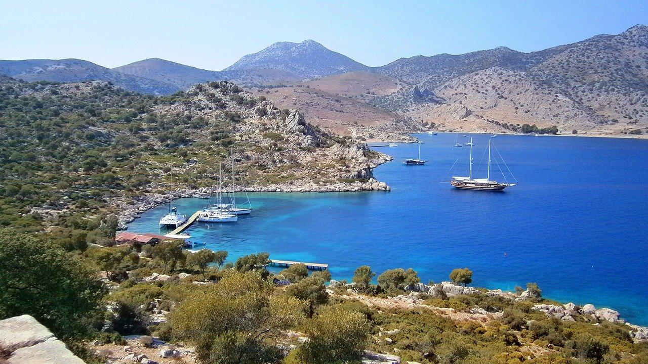
Bozukkale (Loryma)
The ancient city of Bozukkale (Loryma) dates back to the years BC. The nine towers of the castle walls extend out in a rectangular pattern and together with the castle look very solid and well preserved. ''Kale'' means ''corrupted'' so the name may be a consequence of one side of the Castle being missing. Bozukale was used by the British navy many years ago, acting as a shipyard as well. There are great views across the Aegean and everyone can watch the yacht activity out to sea. Its location also resulted in it being a natural stopping off point for yachts sailing in the Aegean. In 395 BC, the Athenian Navy under the commander of Karori is known to have visited while Demetrios, son of Antigonos chose this port to prepare for the attack Rhodes during the Cnidus War in 305 BC.
The bay indents in a NW direction for about 0.8 M. There are considerable depths in the middle. The bight on the east is the best place to be tucked up. Drop anchor in 8-12 m and get a line ashore. The bottom is sand-weed. The winds blow from the valley behind and send swell in.
There are three restaurants in the bay. You can go and pick up laid moorings tailed to the piers. You can moor if you are taking meal at the restaurants. These restaurants provide food with limited set up. Fish menu is advised. They produce their own electricty and they bake bread in the morning. The water is cool and so clean. A rough path goes up to the castle and it is worth making the hike for the view in early morning or late afternoons. The impressive defensive walls are cubic chipped stone blocks without mortar. The castle position almost directly opposite the ancient Greek city of Rhodes, lends support to a theory that it was built by Rhodian craftsmen trying to deny the harbourage to enemy fleets.

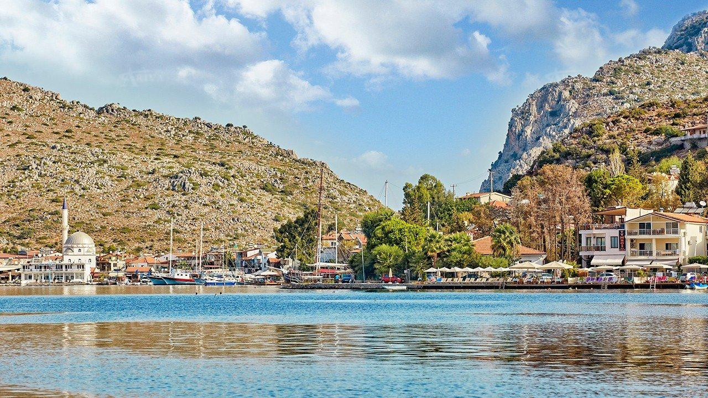
Bozburun
Bozburun, a small town with a marina, 45 kms to the west of Marmaris, has made a name for itself as a place for building quality wooden craft, yachts and gulets. It is well-known to yachtsmen if less visited by others. That said, the lovely winding road by the sea to reach Bozburun is a very pleasant drive. It is not a place for tourists seeking great nightlife but there are many compensations for visitors staying in its small hotels and pensions. There are cozy restaurants around the port, providing good food and service. Mostly fish menus are presented.
There are no laid moorings. Pay attention while easing your chain. Anchors are often tangled between craft lying on opposite quays. An attendant will come and help you to tie up. The municipality manages the port. Water and electricity connections are available. A fee is charged. Fuel is obtained from truck-tanker. All provisions are found in the markets. Public market is arranged on Tuesdays.
The anchorage on the eastern shore off the port is an attractive place for berthing. There are considerable depths at the head. Yachts go stern or bows-to where convenient. A number of bars and pensions are along the shore line. The sun set is magnificient under impressive settings.
Dense vegitation composed of bushes, small trees and maquis. The weather dry in summer, mild and rainy-relatively warm in winter.

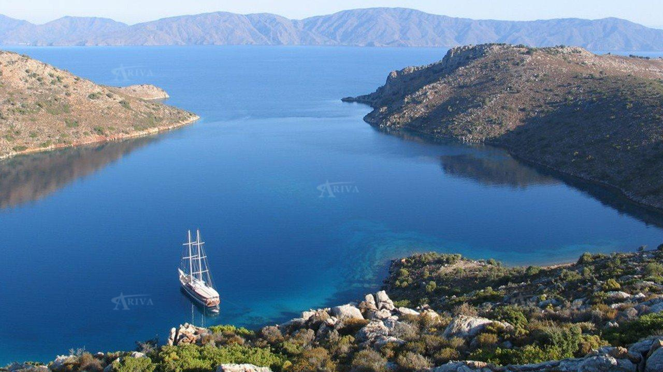
Dirsekbuku
Dirsekbuku lies between the Gulf in the Aegean and the Gulf of Hisonaru, an excellent stopping point for anyone sailing from Bodrum to Marmaris. There are a number of sheltered bays that are ideal for anchorage. The region is so nice it is often difficult to move on from a lovely place with its small islands.
This bay provides the best sheltering among the coves on the SW coast of Hisaronu Bay. It gets swell penetration from the strong northerlies. The bottom is sand. Good holding. There is a cozy restaurant with a quay. Berthing capacity is up to 14 boats.. There are laid moorings tailed on quay. Boats go stern on quay. Laid moorings on your starboard also belong to the restaurant. Boats can be pushed off or anchored with a line ashore. There are floating moorings by the quay. You can pick up and get a line ashore. Fishing boats berth on the southern part of the bay. The restaurant provides good food and service under attractive settings. The water is so clear to recognize the bottom. Dirsek Bükü is one the enchanted places in Hisarönü, the prevailing wind has a welcome cooling effect in summer.

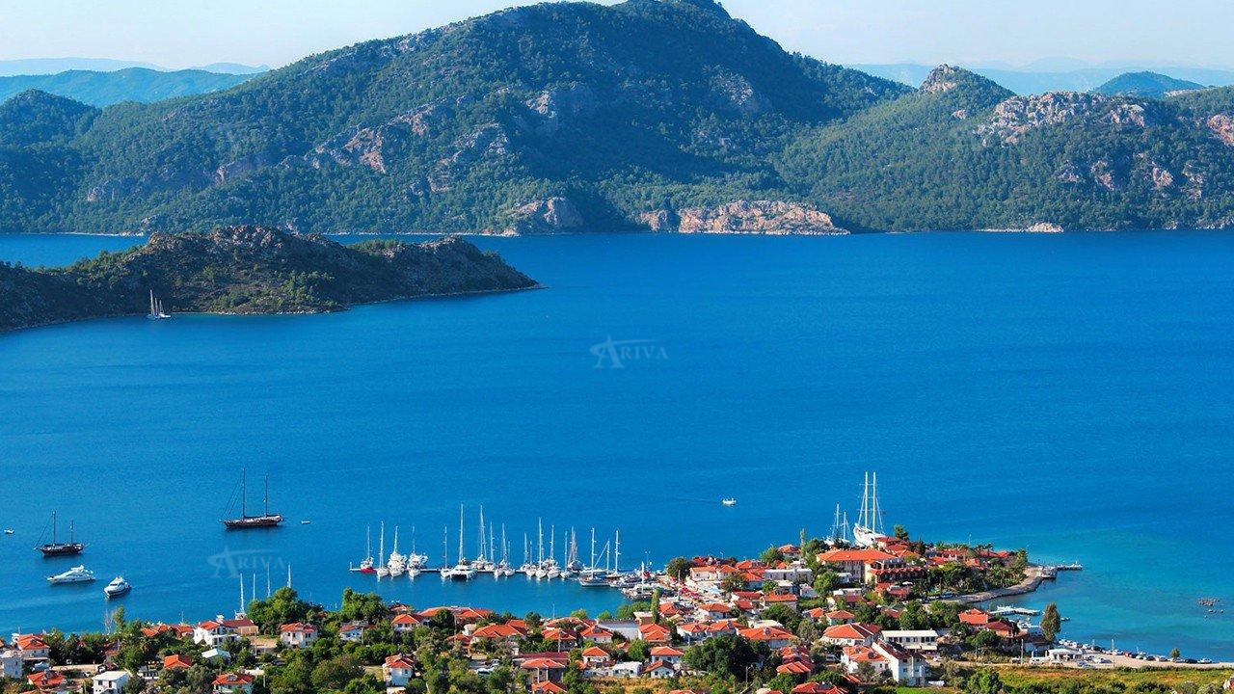
Selimiye Bay
Selimiye Village is one of the real jewels in the Gulf of Hisaronu. As the sun disappears behind the mountains, the village almost seems to change colour into a rich shade of red. There are the ruins of a castle in the hills to the south east. The castle dates back to early Hellenistic times and is one of the reasons why tourists visit. The tomb in the square is 100 metres offshore and helps guide yachts towards the village. Other landmarks include a watch tower, lighthouse, monastery and theatre. Selimiye is known for its beautiful clean sea, the fish that come from it and the fresh fruit, vegetables and herbs from its fertile fields. The pleasant smell of thyme pervades the village.
There are several anchorages in the bay. Çökertme provides adequate anchorage from southerlies. Slipways of the village are located here. Reefs extend out from the islet in the middle and the depths on the west of this islet are shallow to the coast. A stream goes into sea. There are restaurants with piers along the shore. The restaurants mainly offer fish menus. These piers afford adequate shelter from southerlies. A quay and the floating pier of the village here afford the most adequate sheltering. There are laid moorings tailed on pier which provide berthing up to 30 boats. Water and electricty are available. A fee is charged.
Boats go stern to piers there laid moorings tailed on. The depths are sufficient at the head of the piers. There are several piers along to shore infront of the restaurants, you can also go stern-to on these piers. Boats also can be pushed off. The bottom is sand. Good holding. Boats can also go up to the shores of the entry of the bay and drop anchor behind shallow area in 10-20 m and take a line ashore. This part is quite and ideal for those loving serenity.

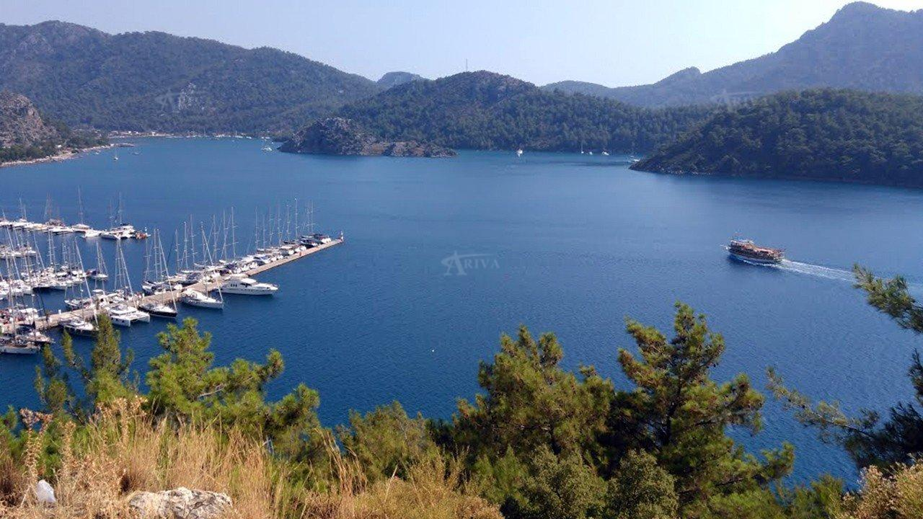
Orhaniye Bay
Featuring its deep blue sea and the legendary Kizkumu beach, Orhaniye is well admired by all holidaymakers. Take a journey down it's quaint village roads to discover the historic castle of the black knight. Floating in this bay, the yachts present a picturesque scene. Thevillage of Orhaniye has lots to offer to a hungry tourist. Enjoy walking down the village or witness the beauty of the busy docks accessed by local and foreign yachtsmen alike, stay indoors or explore the local culture and cuisine of the place. Orhaniye is full of surprises!
The shores are densely wooded by pine trees. Martı Marina stands on your port side at the entry. In the middle part, an island with a castle is spotted. This island is called as Kale Adası. Once Kale Adası is turned and coursed to the west, you come up the most adequate anchorage, providing all-round sheltering. Boats can be anchored off in 8-10m. The bottom is muddy and it provides excellent holding. You can take a line ashore. There is a light and cool breeze in hot summer days. It is a cozy anchorage with attractive settings. A newly built restaurant with pier affods adequate anchorage. Boats go stern to the piers and there laid moorings tailed on. Water and electricty are available. Provisions can be found from market behind.
A sand bank, which is formed by red sand, extends to the south for about 430 m from the coast. The tip of the bank is marked.
It is amazing to see people walking on the sea. There are finger piers here for the tripper boats. Two streams joint into sea on the east of this bank. The bottom comes up quickly to shallow marshy ledge. Approach is to be attempted only by those who are acquinted with the area.
The restaurants with their wooden pier on the south of the bay are also adequate anchorages. Boats go stern to the piers and pick up tailed moorings. Water and electricity can be obtained. Most provisions are found from the markets. Fuel supply is from the truck tanker.
Orhaniye village was formerly called as Kırsaçlı Vasil, derived from Kırvasil of Greek spirit dating from 300 B.C. Bybasos ancient site and Bayır Waterfall (8 km) are worth visiting.

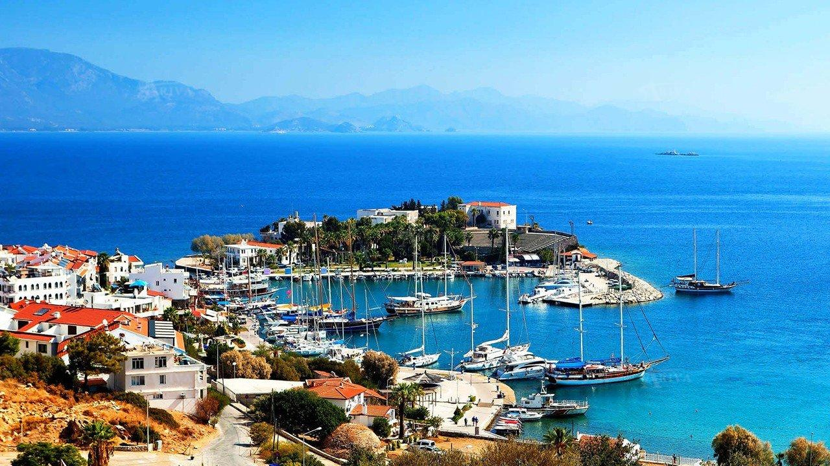
Datca
Datca is a town on the southern shore of the Peninsula of the same name in South West Turkey. It is around 75 kms west of Marmaris and has become a popular spot for yachts heading south down the Aegean and then turning east, or vice versa. There are many small coves on the Peninsula, small farming and fishing communities as well as beaches. It is famous for its tomatoes and olives and despite not having the greenery of some other parts of the Turquoise Coast, it is extremely fertile.
On the northern side of this peninsula, there is a shallow cove where a few boats may push off in the depths 5-6 m. The local boats occupy the quay. This anchorage is fair weather spot. The southern side of the peninsula is the adequate place for berthing. This port is open to south. A short mole extends out and the inlet under this mole is allocated for fishing boats. Coast guard boat berths at the tip of this mole. Boats go stern on quay. Drop your anchor in 5m. The bottom is thick weed and sand. Make sure that your anchor is holding well before you leave your boat unattendant. Datça breeze is well known; it blows down from the passage among the mountains. Especially in winter, southerly gales cause rough sea and make the anchorage untenable. The quay is operated by the municipality. An attendant will guide you and help to tie up. Berthing capacity of the quay is 40 boats. Water and electricty are available. A fee is charged.
All provisions can be obtained. Datça is known for three main foods. Fish, almonds and honey are the main products of the region. There are nice restaurants and bars around the port, providing good food and service. There are nice beaches along the cost. Datça bays are favorite for snorkelling.

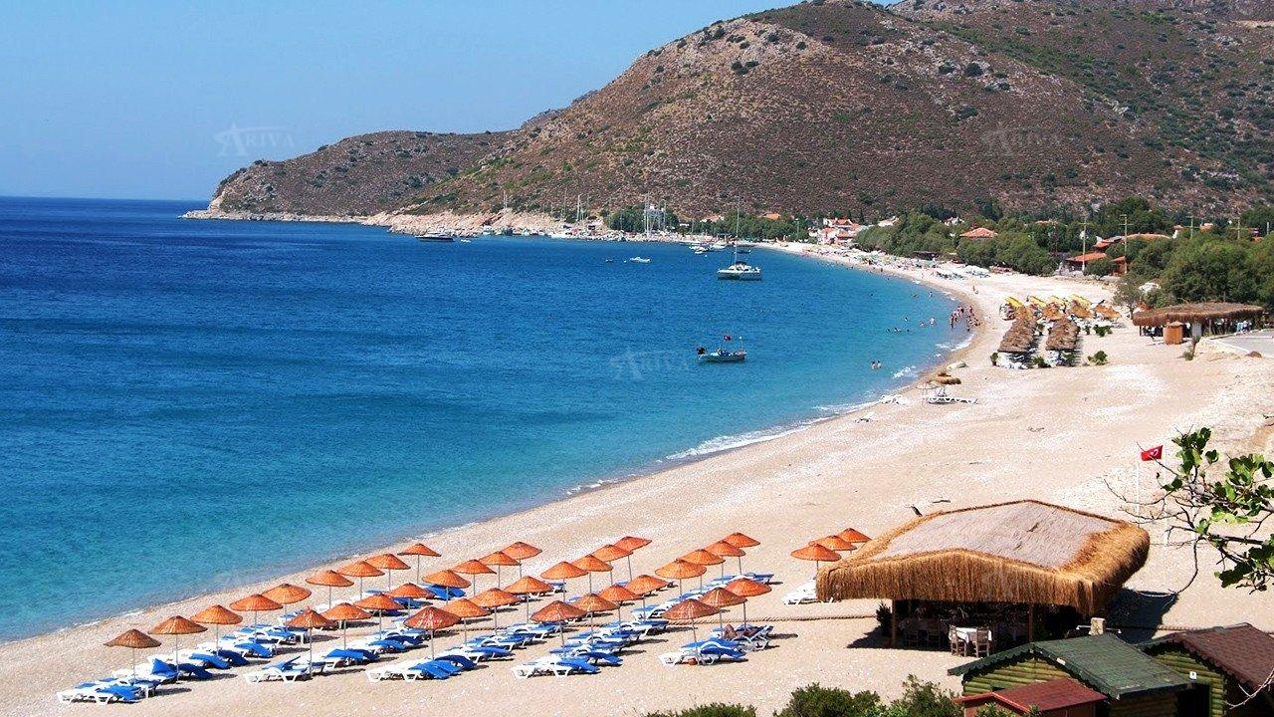
Palamutbuku
Palamutbuku is regarded as having the best beaches in the whole of Datca Peninsula in South West Turkey. The beaches are small but very nice, with the mountains behind. Gardens are colorful and the whole setting is calm and tranquil. It is a great place to get away from crowds and relax. Palamutbuku is at the end of the Peninsula, close to the ruins of the historic city of Knidos; it is just 12 kms away. The warm clear waters are full of fish and you can expect to be able to sample the day’s catch for dinner in the restaurants. It is said that you can see a shiny object on the sea bed it is so clear. There is no need to do anything other than relax and the pace of life is slow. The locals are very hospitable and help make your time in the area even more memorable. It has been described as paradise and it is certainly a place where many yachts sailing in the Dodecanese stop for a while.
There are two coves, Divan Burnu and Palamut Buku port breakwater and they are good for swimming breaks in calm weather. Anchor in 10 m and take a line ashore. You will find sand bottom, then is rocky to shore, ending of a shingle beach. Boats can anchor off the beach and swing at anchor, but this side gets swell even in calm weather. Palamut Buku is open to southerlies, but it provides shelter from northerlies with swell in. While entering into the port, keep some distance off the outer breakwater. The water is shoal by the end of sheltering breakwater. Inside the inlet you will find 4m depths. There are 15 laid moorings tailed on the quay. You can pick up if you find one free, otherwise drop anchor go stern or bows on the quay. Water and electricty are available. A fee is charged.
Most provisions can be obtained from the grocery shops. The restaurans around the port provide good food and they give laundry services as well. Wireless connections are available. Palamut Buku is also governed by the preservation programme, and so it has kept it's identity as a peaceful village-new developments are not allowed. The shore line continues for a few kilometres , characterized by nice beaches, crystal clear water and a few scattered pensions. Almond is especially tasty on the Datca Peninsula. You can see the inhabitans while shelling almonds in autumn.

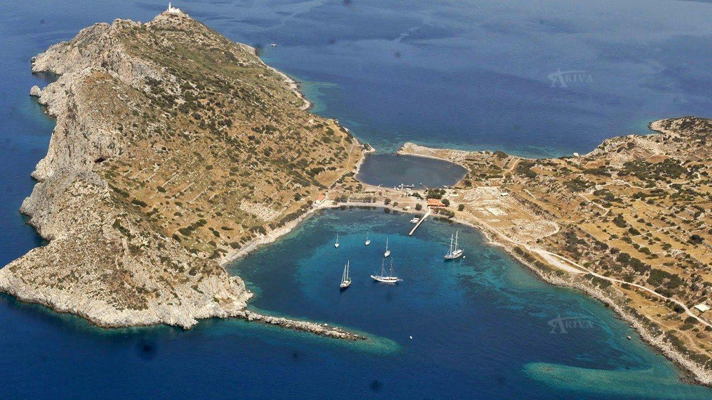
Knidos (Cnidus)
Knidos is at the extreme South West tip of Turkey on the Datca Peninsula. It is commonly regarded as one of the most impressive ancient city ruins in the whole of what was Asia Minor, modern-day Turkey. There is an ancient harbour with a theatre close by. There are two churches just a short walk away. They were built in the Byzantine period and there are extensive excavations that have been going on since 1960. The Statue of Demeter was one of the best discoveries while the lion statues which stood protecting the harbour are in the British Museum in London. The Temple of Aphrodite is a major attraction for visitors as is the necropolis. While Knidos is remote, it is a place that all yacht charters are easily able to visit.
This point is an important turning point for route changes of the vessels. When entering Knidos during the day, you can not see the Knidos light tower. If you do see it, it means you are heading for the sunken rock breakwater. Care is needed. It is safe to keep close to the breakwater on your port side then to drop anchor in 10-12 meters in the middle and swing at anchor as it is common practice here. Severe gusts and choppy sea occurs from the strong westerlies at night. The bottom is thick weed. Make sure that your anchor is well dug in. A wooden pier extends from the head of the inlet. Boats can anchor off with a line ashore. Berthing capacity is 10 boats. Water and electricty are provided. A fee is charged.
There is a cozzy restaurant ashore. Some provisions are available.
If your plan is to go northward, you should heave up your anchor early before breeze gets up to avoid cross swells and choppy sea at Deveboynu Cape.

